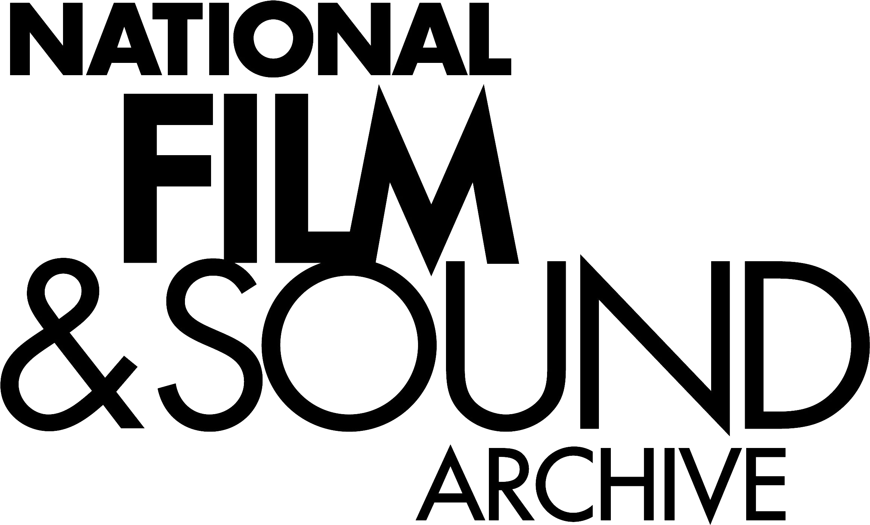

Screen Australia Stage 2 Review – Industry Support Programs

Submission by the National Film and Sound Archive
The following is a submission by the National Film and Sound Archive (NFSA) in response to the Stage 2 of the ‘Review of Screen Industry Support Programs’. The NFSA appreciates the opportunity to comment on these matters.
Marketing Support and Promotion
Embassy Roadshow
The NFSA supports the programming of Australian film festivals and screenings at Australian embassies and consulates overseas as an important contribution to raising the profile of Australia’s filmmaking work and production opportunity internationally.
Embassy Roadshow complements the NFSA’s international film lending activities to film festivals and other cultural heritage activities. Lending activity has increased steadily in recent years with growing international interest in Australia’s film history and cultural heritage over a widening range of eras. NFSA is steadily increasing its levels of restoration of key titles from Australia’s cinema history and would be interested in exploring opportunities for the inclusion of archival film material in Embassy Roadshow. NFSA is also interested in exploring the possibilities of including more Indigenous material in the Embassy Roadshow collection.
Library
The Library of film footage and stills from Screen Australia’s archives (archives of the former Film Australia and titles commissioned since 2008 by Screen Australia) is a collection of substantial historic cultural value.
The NFSA is very keen that the material held in this collection continues to be as accessible as possible to all Australians in order to help advance understanding of the wide range of interests covered by the collection. The collection closely complements the NFSA’s national collection of over 1.4 million items and many of the users of our collection also draw on the Library of film footage and stills at Screen Australia.
Part of the NFSA’s remit is to provide national leadership in support of the care and protection of Australia’s national audiovisual heritage to help ensure as much of this material is preserved for posterity and the enjoyment and interest of future generations. A range of activities support this goal including policy leadership, relevant scientific research, provision of specialist archival advice and operating the National Registry of Audiovisual Collections which holds details of audiovisual collections from across Australia. The NFSA is keen to see the Library of film footage and stills at Screen Australia continue to be well cared for in the interest of future Australians. The NFSA also acknowledges the collection has benefits as a major resource for documentary filmmakers, film historians and academics.
Digital Learning
The NFSA’s program australianscreenonline is a substantial online education resource. The program has a range of partners including many of Australia’s national collecting institutions and the Curriculum Corporation. The NFSA notes the Digital Learning programs stated objectives include a focus on the education sector. We are keen for these two programs with similar objectives to work closely together in a complementary way that ensures there is no overlap of government effort and resources in delivering online education and learning resources. The NFSA is also concerned that Digital Learning programs continue to provide access to the Screen Australia Library to the education sector through the production of online learning resources.
Research and Statistics
A number of NFSA programs are directly reliant on production and statistical information including australianscreenonline and the ongoing building of the national collection. The NFSA hopes that its existing arrangements with Screen Australia can be continued and expanded.
Data collated by Screen Australia on current production: feature film, documentary and TV dramas is provided to the NFSA and is valuable in the prioritising of collection acquisition and cataloguing of the national collection. It also helps the NFSA develop information in the national collection management database.
The NFSA is interested in discussing the possibility of further enhancing production information, such as the addition of full credits information. We are also interested in exploring possibilities for increasing data sharing including using newer technologies to export data to the NFSA collection management system.
A central source of authoritative information on the industry is an important resource for researchers who are often accessing the NFSA’s national collection. We also receive a range of queries which fall outside NFSA’s scope and which we refer to Screen Australia’s reference service.
SUMMARY COMMENT
Given that many of the programs and services currently under review relate closely to key business of the NFSA and its remit of providing access to Australia’s audiovisual cultural history, the NFSA looks forward to a close partnering with Screen Australia to ensure continued and successful delivery of these programs and services.

